Heat Transfer Notes
CONDUCTION – transfer of energy from particle to particle through ________________. Particles at higher ______________________ have more _______________ and _______________ further. They collide with cooler air and spread energy through the material. Heat travels by conduction mainly through _________________.
CONVECTION – transfer of energy by the movement of the material, particularly in _______________ and ___________________ because they flow. When a fluid(gas or liquid) is heated, it becomes less _______________ and it is pushed ___________________ by cooler, more dense fluids that _____________. This causes a ________________ that moves heat.
RADIATION – transfer of energy that doesn’t need _________________. The source of radiant energy is mostly the ______________. Radiant energy can travel through space where there is ______ matter.

Beneath each picture, write the method of heating that is taking place. (conduction, convection, or radiation)
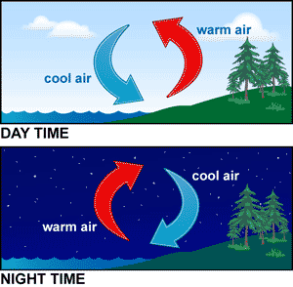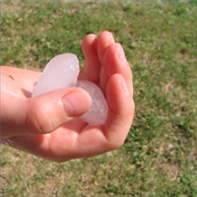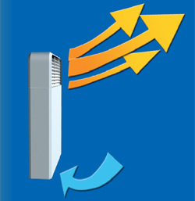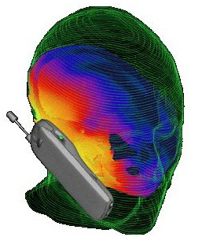



Give explanations that answer these questions.
- How does heat get from the stove burner into your soup? _________________________________________ ______________________________________________________________________________________________________________________________________________________________________________________
- How does a cooler keep drinks cold on a hot day? __________________________________________________ ___________________________________________________________________________________________
- When two cars sit in the sun all day, the one with the black roof gets hotter than the one with the white, shiny roof. Why? _________________________________________________________________________________ ______________________________________________________________________________________________________________________________________________________________________________________
- How does the heat from the sun, thousands of miles away, reach your body? ____________________________ ______________________________________________________________________________________________________________________________________________________________________________________
- Why is the metal spoon in your cup of hot chocolate hot? ____________________________________________ ___________________________________________________________________________________________
- Why doesn’t a plastic spoon in hot chocolate feel hot? _______________________________________________ ___________________________________________________________________________________________
- Why is your house warm on a cold day, even if you haven’t turned on the heat? __________________________ ___________________________________________________________________________________________
- When you turn on a heater, how does the warmth get to you? ________________________________________ ___________________________________________________________________________________________
- Why are you warmer with several layers of clothes than with just one heavy jacket? _______________________ ______________________________________________________________________________________________________________________________________________________________________________________
- Why do some cooking pots have wooden handles? __________________________________________________ ___________________________________________________________________________________________
- How does a cold can of soda become warm on a hot day? ____________________________________________ ___________________________________________________________________________________________
- How does a microwave oven get your food hot? ____________________________________________________ ___________________________________________________________________________________________
- How can a solar heating system heat your water on a day when there’s no sun? __________________________ ______________________________________________________________________________________________________________________________________________________________________________________
- How is a refrigerator an example of a heat mover? __________________________________________________ ___________________________________________________________________________________________
- How can temperature (heat) be pollution? ________________________________________________________ ___________________________________________________________________________________________
- Why does clean snow melt more slowly than dirty snow? _____________________________________________ ___________________________________________________________________________________________
- Why is the attic of a house always warmer than the basement? ________________________________________ ___________________________________________________________________________________________

Teacher’s Answer Key - Heat Transfer Notes
CONDUCTION – transfer of energy from particle to particle through matter. Particles at higher temperatures have more energy and vibrate further. They collide with cooler air and spread energy through the material. Heat travels by conduction mainly through solids.
CONVECTION – transfer of energy by the movement of the material, particularly in gases and liquids because they flow. When a fluid (gas or liquid) is heated, it becomes less dense and it is pushed upward by cooler, more dense fluids that sink. This causes a current that moves heat.
RADIATION – transfer of energy that doesn’t need matter. The source of radiant energy is mostly the sun. Radiant energy can travel through space where there is no matter.

Beneath each picture, write the method of heating that is taking place. (conduction, convection, or radiation)
CONVECTION CONDUCTION CONVECTION RADIATION
RADIATION CONDUCTION RADIATION

Give explanations that answer these questions.
- How does heat get from the stove burner into your soup? Heat from the burner warms the pan by conduction. The liquid soup is warmed by convection currents.
- How does a cooler keep drinks cold on a hot day? The cooler has insulating material – something that is a poor conductor and does not allow thermal energy to transfer well.
- When two cars sit in the sun all day, the one with the black roof gets hotter than the one with the white, shiny roof. Why? Black absorbs radiant energy from the sun. White or shiny objects reflect the sun’s energy.
- How does the heat from the sun, thousands of miles away, reach your body? By radiation
- Why is the metal spoon in your cup of hot chocolate hot? Metal is a good conductor of heat. The heat energy moves from the hot liquid through the spoon by conduction.
- Why doesn’t a plastic spoon in hot chocolate feel hot? Plastic is a poor conductor of heat energy.
- Why is your house warm on a cold day, even if you haven’t turned on the heat? Houses are usually insulated with materials that do not transfer thermal energy well. Heat usually flows from warmest spots to cooler spots. The insulating materials hold the heat in the house.
- When you turn on a heater, how does the warmth get to you? The warmth travels through the air by convection.
- Why are you warmer with several layers of clothes than with just one heavy jacket? When you wear layers, air is trapped between layers. Your body heat warms these many pockets of air, and they add extra insulation to keep in your body heat.
- Why do some cooking pots have wooden handles? Wood is a poor conductor of heat – this is a protection to keep hands from burning.
- How does a cold can of soda become warm on a hot day? Heat energy outside the can warms the metal can (a good conductor) by conduction. Warmth from the surface of the can then transfers through the liquid by convection.
- How does a microwave oven get your food hot? Microwaves carry radiant energy to the food. This causes the molecules in the food to vibrate rapidly and produce thermal energy (heat).
- How can a solar heating system heat your water on a day when there’s no sun? A solar heating system includes containers that store the heat collected on a sunny day. This heat is stored in such materials as hot water or stones.
- How is a refrigerator an example of a heat mover? A refrigerator is a heat mover because it removes heat from the food inside a cool space and puts the heat out into the room at a higher temperature (warm air comes out of the back of the refrigerator).
- How can temperature (heat) be pollution? Extra heat in the environment is called thermal pollution because it can raise the temperature of the environment and change the ecosystem, causing danger to some life forms.
- Why does clean snow melt more slowly than dirty snow? Dirt in the snow is dark in color and absorbs radiant energy from the sun. This causes the snow to melt. Clean snow reflects more of the sun’s heat energy away.
- Why is the attic of a house always warmer than the basement? Air is heated by convection. Warm air is always less dense and lighter. Heavier, denser, cooler air sinks and pushes warmer air upward.

